位置:   
File -> Other Settings -> Default Settings (command + “,”)   
File and Code Templates -> Includes -> File Header -> 编辑

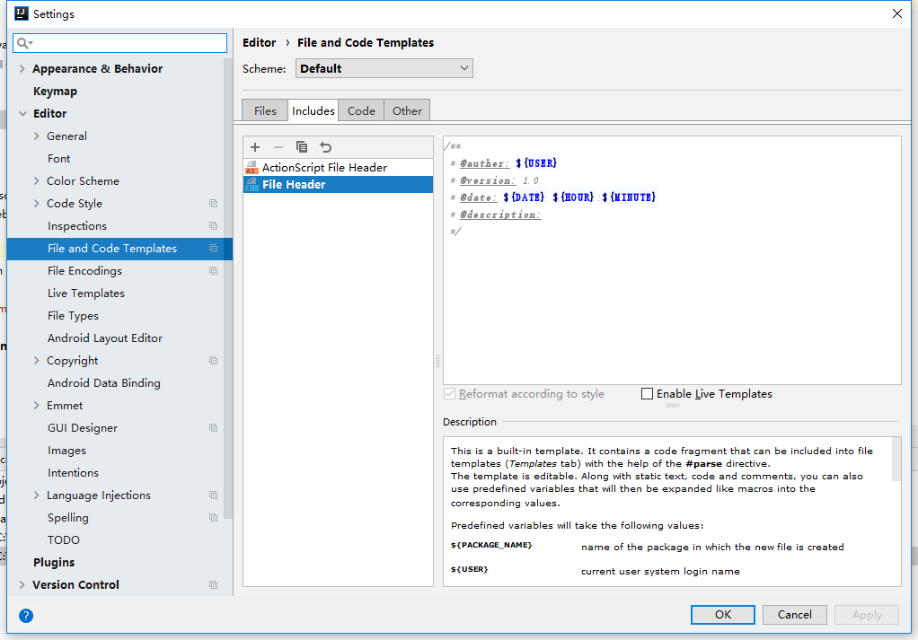

/**  
 * @auther: **${USER}** * @version: 1.0  
 * @date: **${DATE} ${HOUR}**:**${MINUTE}** * @description:   
 */